Project - Design

Garcia Campos, Jesus
Karimi, Niloufar
Oleru, Victory
Sass, Ashley
Sian, Tasha

School of Technology, Bow Valley College
SODV1201 – Introduction to Web Programing
Dima Marachi
May 27, 2026

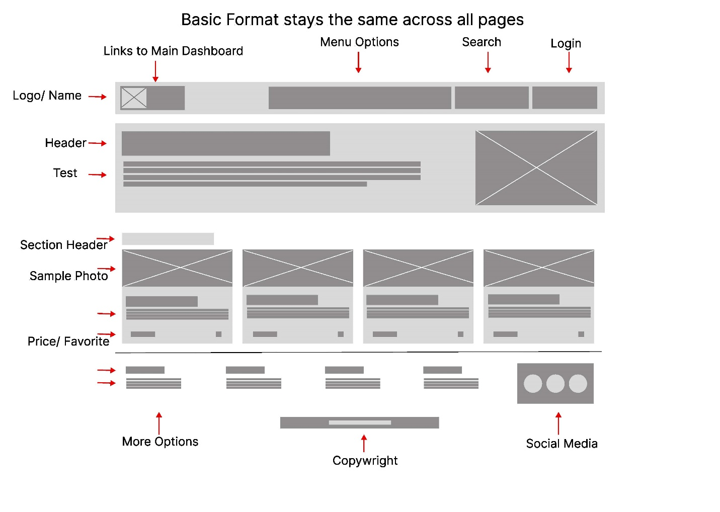
Text
This is the landing page; it will be the center hub where you can see everything at a glance. This will be the standard page for all the following pages with the same elements following the design then this one displays. There will also be a logo and Name that kinks back to the landing page.
Here will be the main menu options that will direct you to any page you need.
These will be finding works spaces(client), listing a space you have(owner), a search feature for browsing, as well as your login/ sign up option
The top will be the hero image showcasing the tagline and brief description of what the site will offer alongside a photo for interest.
Below are examples of the properties offered, with the name, neighborhood, square footage, and price at first glance, alongside photos for visual interest.
The footer of this page will also contain additional information about the company and resources you need to learn more about what they stand for. Along with links to social media. And the Copyright information for the company. These links will just be for show in this assignment but are standard in all web pages.
The navigation bar and the footer will be standard across all pages. With the menu options changing slightly between pages. The layout for content in the displays will also be standard. (Photo, name, neighborhood, square footage, price – and amenities and description in the larger sections)
Register Page
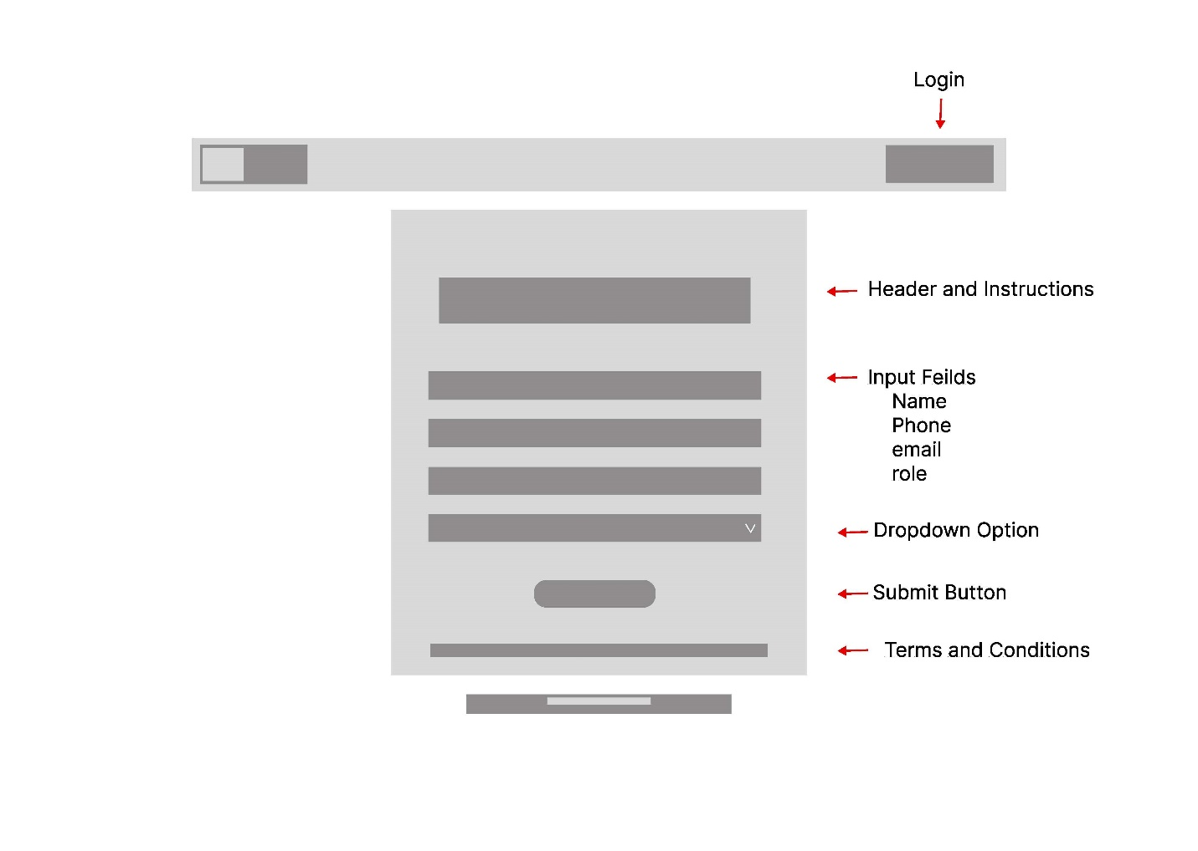
Login Page
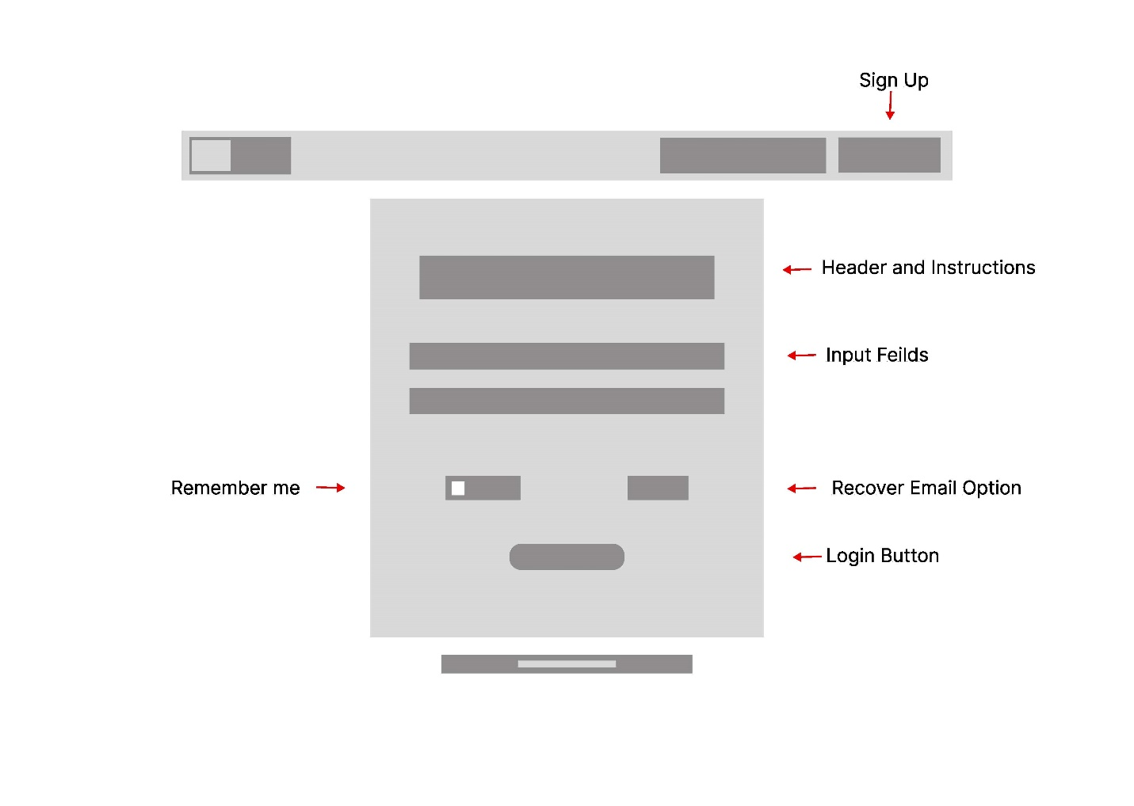

Add Property Page (Owner)
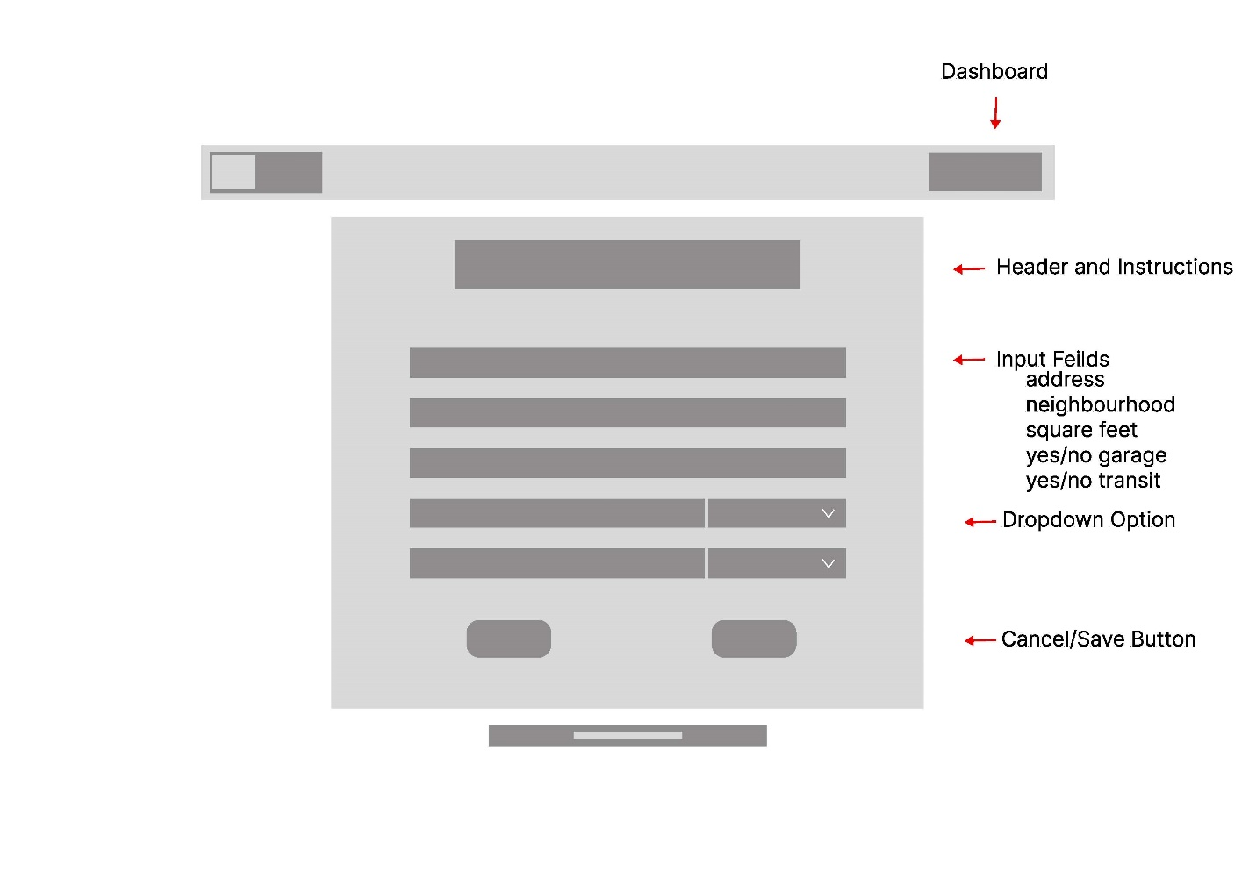
Add Workspace Page (Owner)
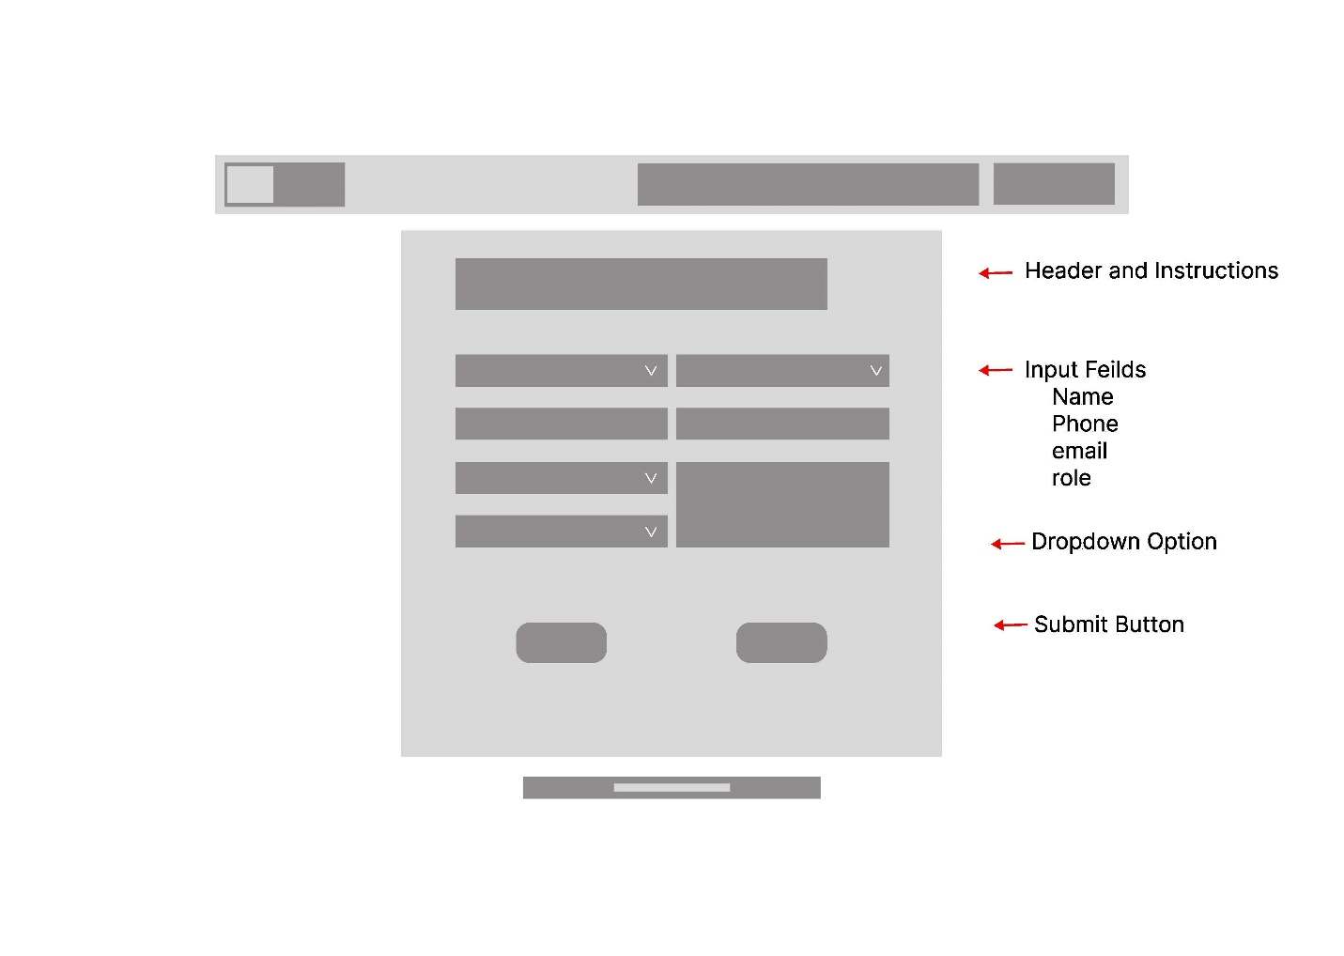

Profile Page/Dashboard
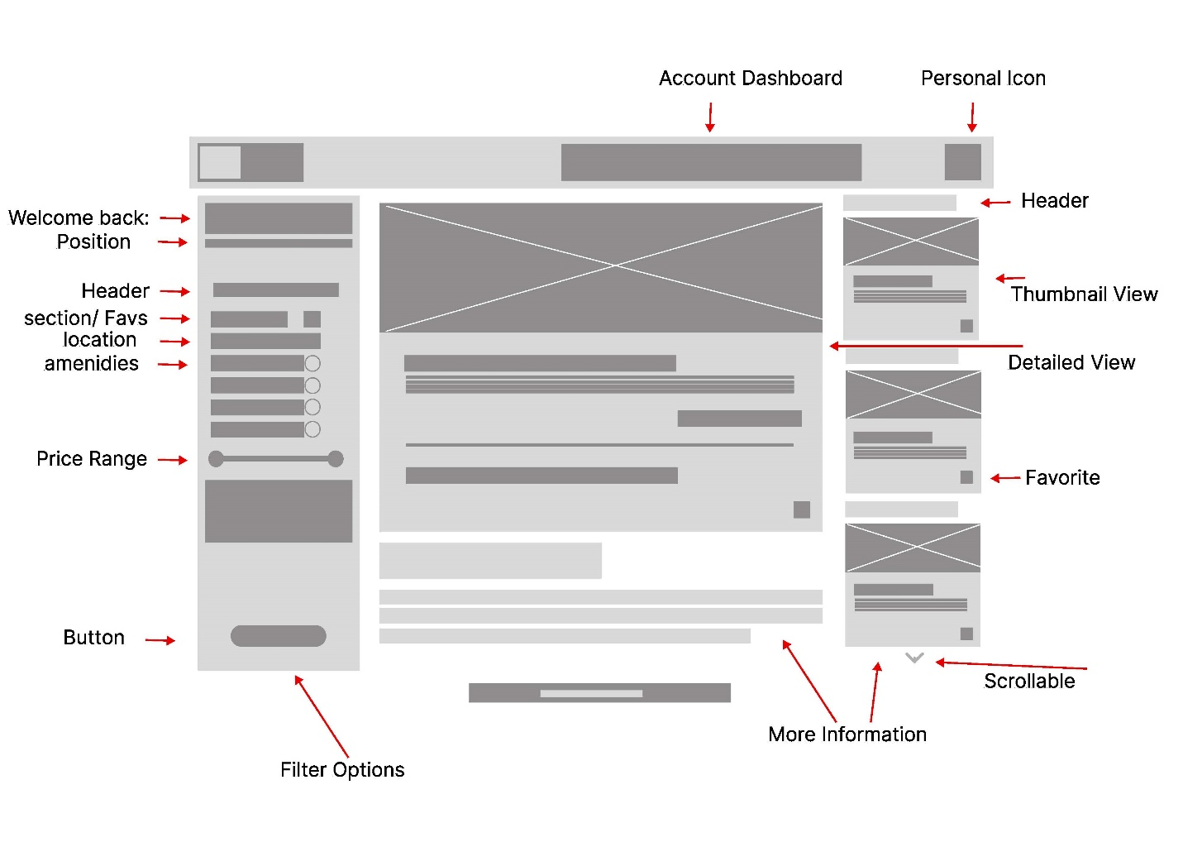
This is the profile page/dashboard where you can see your profile, it will list whether you are a client or owner as well as allow you to quickly search among your favorite locations for easy viewing.
This will have a large and very detailed listing of favorite properties and or search results. This will be scrollable. This information will include Photo(s), name, neighborhood, square footage, price, amenities and description. As well as a scrollable section of related listings for the displayed property.
The menu will have the logo/name taking you back to the dashboard as well as an option for the main search page, listing your own space, and your profile.

Search Listings Page
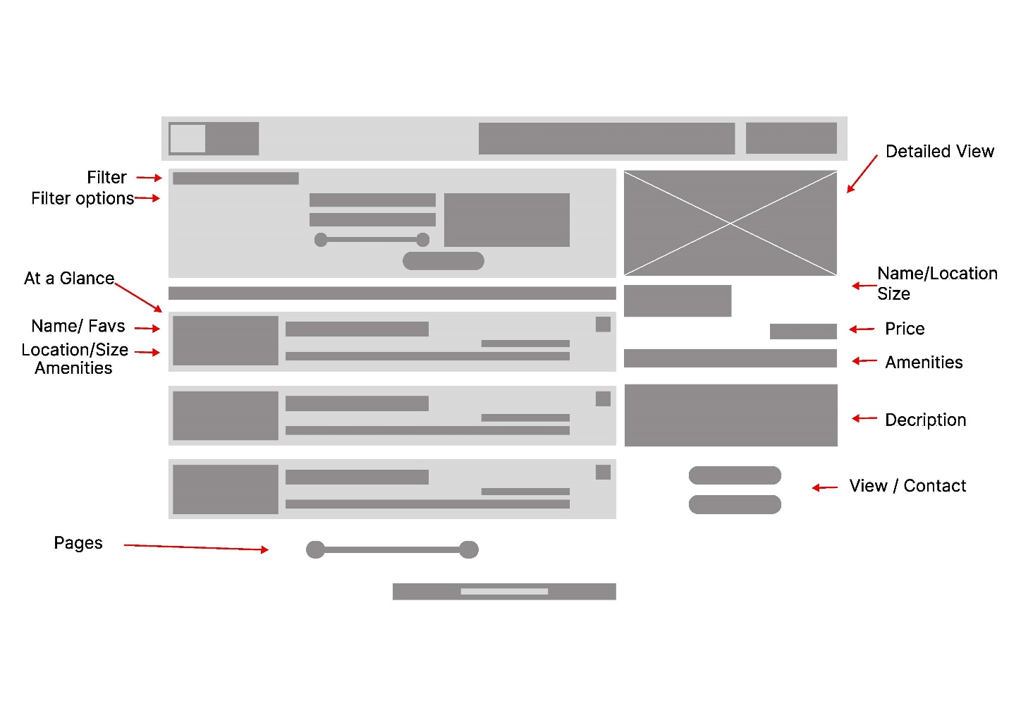

This page will be where you search for listings you are looking for the concept will be very similar to the profile page with the search feature being more of a drop-down menu style, and have access to all listings not just what you have favorited. You will have small listings you can go see with pages to switch though and a large display on the side for any that you click on.
The side selection will feature the Photo(s), name, neighborhood, square footage, price, amenities and a small description. You will then also have the opportunity to view more details or contact the lister.
The navigation bar will take you to your profile, add a work/space property or back to the landing page.

Reference Page:
Webflow Showcase Template Webflow. (n.g.). Coworking websites. Made in Webflow. https://webflow.com/made-in-webflow/coworking
Rocket Template Rocket. (n.d.). Workspace - Electric coworking landing page template. https://www.rocket.new/templates/workspace-electric-coworking-landing-page-template
Regus Blog/Guide Regus. (n.d.). A guide to coworking in Calgary. https://www.regus.com/en/ca/alberta/calgary/coworking/a-guide-to-coworking-in-calgary
Flux Academy Blog Alexander, O. (2023, June 20). 20 wireframe examples for web design. Flux Academy. https://www.flux-academy.com/blog/20-wireframe-examples-for-web-design
Visual Paradigm Handbook Visual Paradigm. (n.d.). What is wireframe? Agile Project Management Handbook. https://www.visual-paradigm.com/learning/handbooks/agile-handbook/wireframe.jsp

AI was used to clarify information from description.

